Semi-structured data and Advanced Data Modelling

Coursework 1 MongoDB Design and Implementation

Submission date: Friday the 9th of November 2018

Requirements

You have been commissioned to design and build a database for an airline company. The system is required to store information about the Company and support a number of queries against the database.

The system is required to store details of the following aspects of the business:

1)Pilots: including details of their address, their other contact details and information about their employment record with the Company, the date of their last “fit for flying” test

2) Planes: details of their make, model, flying range (with a full fuel load), length of service, status (i.e. working, being repaired or upgraded etc), seating capacity

3) plane flights: including the plane making the flight, starting point, final destination, including the dates/times of departure and arrival, the pilot assigned to the flight.

4) Flight bookings: including date/time the booking was made, who made the booking, the passengers on the booking, flights used to get from the start to the final destination (note that a booking might involve the use of more than one plane flight), the total cost of the booking

5) Airports: including the name, location, cost of use (as a simplification, you can assume that each airport charges a fixed hourly rate for the length of time a plane stops at an airport, plus a further fixed charge for refueling, both of these charges will vary from airport to airport)

6) Journeys: including journey id, starting airport, destination airport, journey length (in kilometers)

7) Airline employees: as a simplified staffing model, you can assume the airline employs booking clerks, maintenance staff, pilots, cabin staff.

8) Revenue: you need to be able to calculate the total revenue made or lossed by the airline. The most simple model of this can be calculated as: ///

Revenue = total money from bookings – airport costs – total salary bill

Deliverables

You are required to produce the following:

1. A list of any assumptions you have made during the development of your system
2. A UML class or ER diagram of the entities and relationships in your system design
3. A text description of the entities, relationships and attributes in your system. This section should also include any brief explanation of your design you feel is required, particularly paying attention to less obvious design choices.
4. A MongoDB script to populate the collections in your design. For most collections between 6-10 documents should be sufficient. However you should design your test data to make sure that it will demonstrate that your MongoD
5. B queries will work robustly no matter what data is stored.
6. A set of queries to extract information from the system. You should aim to use a good range of language constructs to demonstrate your understanding of the language.
7. A section describing the use of the Explain and Profiling utilities to examine what happens when you run 3 or 4 of your more advanced queries. Other performance-related tools may be used if desired.
8. A discussion section reflecting on how your design is similar to and different from that which you might have created for a relational system.  
   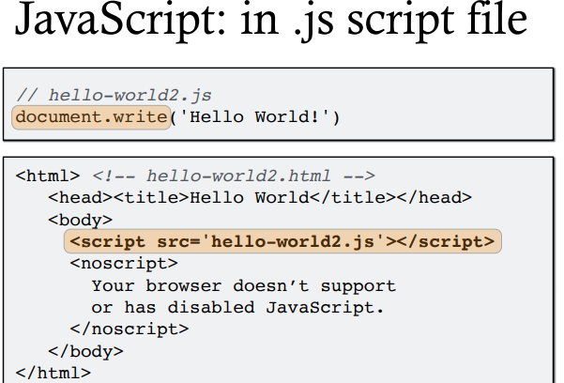

* Model Relationship Between Documents
* Model Tree Structures
* Model Specific Application Contexts

<http://www.boeing.com/commercial/>

Marking scheme for coursework 1

The following notes are provided to assist you in judging the standard of work required for your coursework submission.

Undergraduate:

To obtain a mark above 70%: all parts of the required work must be completed to an excellent standard, including a high level of detail and accuracy. Evidence of an ability to address issues beyond the given specification, and use of materials beyond those in the taught course will normally be expected for this grade. For example, part F on performance tuning is likely to be particularly well done by groups earning this grade, though not at the expense of work on other parts of the assignment.

To obtain a mark between 60-69%: Most parts of the work will be completed to a high standard of detail and accuracy, though the work may include a small number of minor errors. The work should demonstrate a good a consistent level of ability across the full range of requested deliverables. The work may at times demonstrate the characteristics of work deserving of a mark over 70%, but at the same time include flaws which prevent it from being rated at that level.

To obtain a mark between 50-59% Most deliverables should be developed in a competent manner, though a higher number of minor errors, or a small number of more significant errors may be present.

To obtain a mark between 40-49%: the work must demonstrate some real understanding and competence by the students, provide a serious attempt at all of the requested aspects of the work, though parts of it will contain significant errors of design and/or implementation.

Postgraduate

To obtain a mark above 70%: all parts of the required work must be completed to an excellent standard, including a high level of detail and accuracy. Evidence of an ability to address issues beyond the given specification, to critically analyse different approaches and the use of materials beyond those in the taught course will normally be expected for this grade. The work on performance tuning (part F) is particularly likely to be well done by groups earning this grade, though not at the expense of other parts of the work.

To obtain a mark between 65-69%: Most parts of the work will be completed to a high standard of detail and accuracy, though the work may include a small number of minor errors. The work should demonstrate a good a consistent level of ability across the full range of requested deliverables. The work may at times demonstrate the characteristics of work deserving of a mark over 70%, but at the same time include flaws which prevent it from being rated at that level. The work should provide evidence of analytical ability and critical understanding of different design and implementation approaches.

To obtain a mark between 60-64% Most deliverables should be developed in a competent manner, though a higher number of minor errors, or a small number of more significant errors may be present. The work should provide evidence of analytical ability.

To obtain a mark between 50-59%: the work must demonstrate some real understanding and competence by the students, provide a serious attempt at all of the requested aspects of the work, though parts of it will contain significant errors of design and/or implementation.

Guidelines specific to the coursework:

1. Provide concise but clear comments explaining why your design/implementation is the way it is, and, where appropriate, why you have rejected apparently good alternatives.
2. Beware assumptions that simplify the problem. On the contrary, evidence that you have tried to address design or implementation issues that are typical of realistic situations will be rewarded. State all assumptions clearly.
3. When writing your report, put yourself in the place of the person marking it rather than the person writing it, what is obvious to you having worked on the system may not be so obvius to someone looking at your work for the first time.
4. Make sure you read the specification carefully, and that you submit all of the required deliverables in the format requested.
5. Everyone in the group take responsibility for the final version of the entire coursework.
6. Design: the main point here is to explain your design decisions clearly so that I can understand the choices you have made.

Chapter4

page33